# GENERAL INFORMATION

# 1.0 GENERAL INFORMATION

### 1.1 System Overview

Explain in general terms the system and the purpose for which it is intended. The description shall include:

1. **YAVATAN System,** is digital mission strategy system that manages the organization’s events and its attributes and other components – activities, logistics and its attendance.
2. **YAVATAN** is made through web application and its database is made and implemented using MySQL and PhpMyAdmin as server, and can only be used in online mode.
3. The user access of **YAVATAN** is divided into three: The member user or the volunteer, the group leader, and the system administrator. The volunteer can view available and related groups and events that the user can join or register. The group leader can create events, manage group members and other group and event configurations. The administrator can add, edit, delete, view and archive data and any other related entities into the system.
4. **YAVATAN** is maintained by the system administrator and any concerns or technicalities shall be addressed to and by the system administrator.

## 1.2 Project References

Below are the reference(s) used for the development and implementation of the Yavatan:

* EventPro: Professional Venue, Event and Catering Management Software

## 1.3 Authorized Use Permission

This user’s manual is protected by the copyright policy. Any modification, reproduction or infringement of this document without authorization is strictly restricted.

**1.4 Points of Contact**

**1.4.1 Information**

Any concerns relating to the functionalities and condition of the website shall be reported to the website developer Mr. Cristian Balatbat. In case of emergency, please contact the system developer.

Cristian Balatbat

Software Research Group

Programmer

09967742086 / cristianbalatbat@yahoo.com

**1.5 Important Terms and their Definition**

event Management System – system that manages the different assets and aspects of event, organization, and configurations of its entities, and also holds the records of the events affecting the changes in its assets.

DATABASE - group of files used to store data pertaining to a single business process.

PHPMYADMIN - a localhost server and a relational database management system software that provides database engine, libraries, and access that will be used by the system.

ADMINISTRATOR – a person responsible for the performance or management of administrative business operations

DEmographIC - relating to the dynamic balance of a population especially with regard to density and capacity.

RELIGION - commitment or devotion to religious faith or observance.

CHURCH - the clergy or officialdom of a religious body.

# 2.0 SYSTEM SUMMARY

# 2.0 SYSTEM SUMMARY

*This section provides the brief information of how the system work and what flow does it follow.*

## 2.1 System Configuration

Yavatan is a web-based system, so it can run on different web browsers and if its uploaded in the web, you will be needing an internet connection in order to access the system. If you wish to maintain the website or change some information on it, and if you need to have an administrative access to the data, you will need to use phpMyAdmin for databasing and local hosting.

## 2.2 Data Flows

Yavatan enables the volunteer can view available and related groups and events that the user can join or register. The group leader can create events, manage group members and other group and event configurations. The administrator can add, edit, delete, view and archive data and any other related entities into the system.

**2.3 User Access Levels**

Yavatan has three (3) level of access that accompanies certain access rights. These are the following details:

|  |  |
| --- | --- |
| USER | ACCESS RIGHTS |
| Volunteer | This user access has the ability to view available and related groups and events that the user can join or register. |
| Group Leader | This user access has the ability to events, manage group members and other group and event configurations |
| System Administrator | This user access has the ability to add, edit, delete, view and archive data and any other related entities into the system. |

## 2.4 Contingencies and Alternate Modes of Operation

In the event of emergency, disaster, or accident the system may encounter server or hardware problem which may cause the system go into an error, Yavatan may be transferred and operated on a different computer and serve as its sole server to keep the continuity of the service.

# 3.0 GETTING STARTED

# 3.0 GETTING STARTED

*This section provides a general walkthrough of the system from initiation through exit. It provides details on how to log in on the system.*

## 3.1 Homepage

The system provides a homepage or portal to show a brief information about the yavatan system.

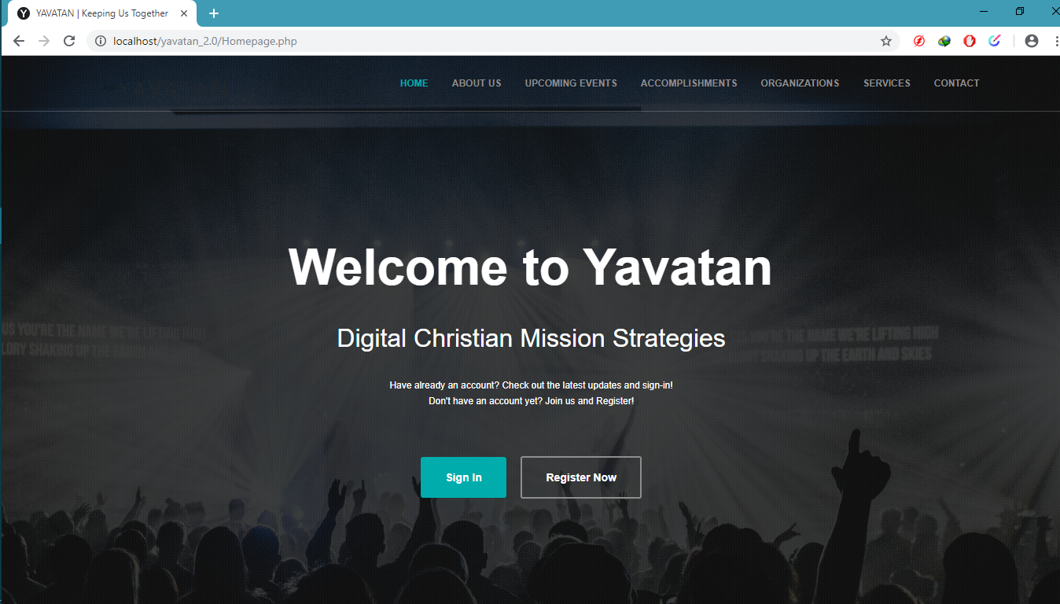

Click to redirect to the registration page

Click to redirect to the login page

## 3.2 Logging On

The system developer will provide the default username and password to the administrator, while the volunteer user will have to register in order to have a personal account to the system, and the group leader user will be created by the administrator.

* In the Volunteer user, The Main Home Page of the system will be displayed after logging in.
* If you are a new user, go to “Register Now”. Fill up all the required information and follow the step by step process.
* In the Group Leader user, The Dashboard Page of the system will be displayed where you can see the summary or analytics of system.
* In the Administrator user, after logging in, you will be redirected to system’s dashboard.

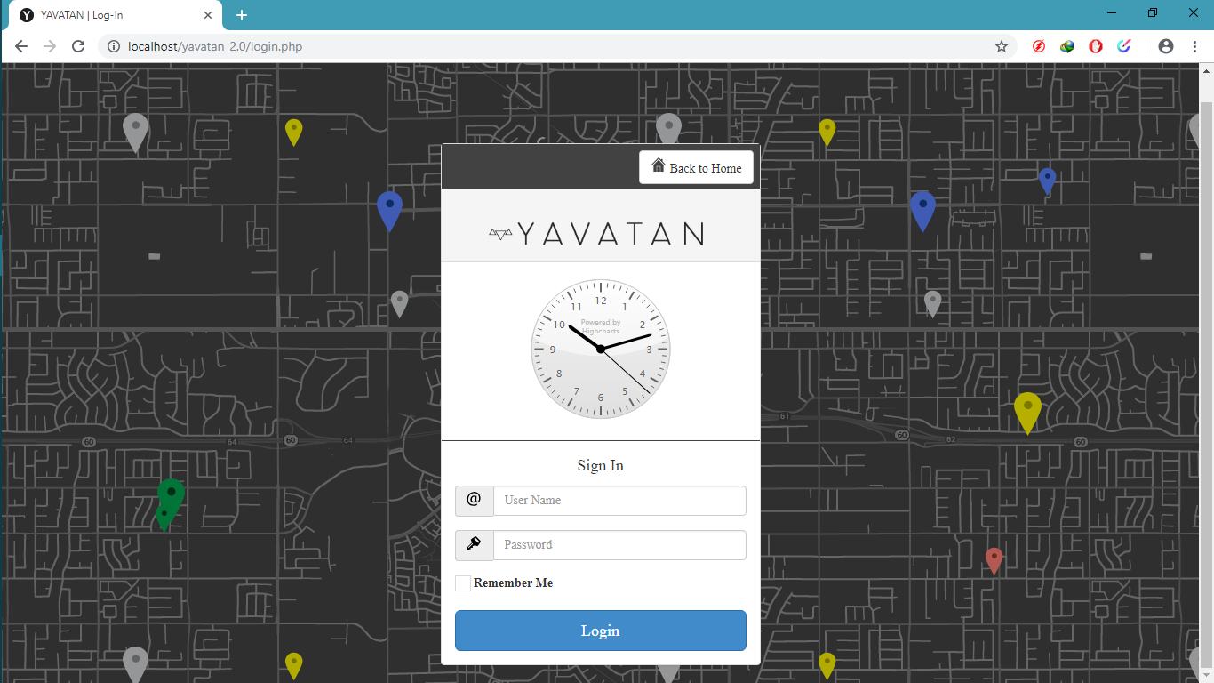

Click to proceed

Click when you want to remember your account

Fill in your password

Fill in your username

## 3.3 Registration

Registration page is provided in order to register new users and marked as volunteer users.

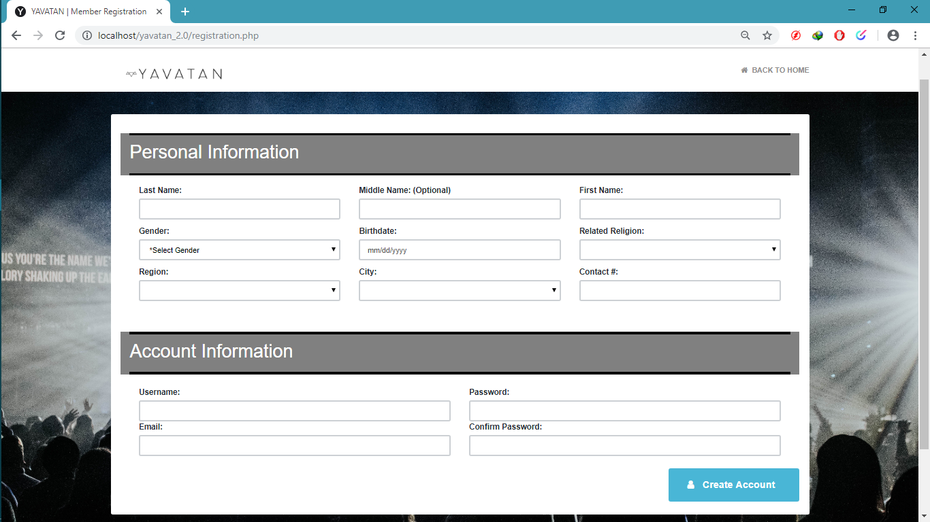

Once you fill up all the required fields just click this to register

Fill up all the required information

## 3.4 System Menu and Page Description

*This section describes the menus and page navigations available on the system for the volunteer user access, group leader user access and administrator access.*

### 3.4.1 Administrator Menu and Page Navigation

*The menus and pages available for the administrator are illustrated in the following:*

|  |  |
| --- | --- |
| Screen/Page | Description |
| Dashboard | Once you logged in, this page will show where you can see the analytics of the system. |
| User Management | A part of a system that you can manage User Roles, Account Management, Group/Organization Management, Group-Leader Management. |
| Demographics | This page is where you can manage regions and cities. |
| Yavatan Configurations | This is where the administrator manages Religion, Church, Event Type and Event Audience. |

### 3.4.2 Group-Leader Menu and Page Navigation

*The menus and pages available for the group-leader user are illustrated in the following:*

|  |  |
| --- | --- |
| Screen/Page | Description |
| Dashboard | This page will show where you can see the analytics for the group-leader account. |
| Event Management | A part of a system that you can manage events, add events, view event details, manage activities, add activities, view activity details, manage logistics and manage attendance. |
| Group Management | This page is where you can manage Group Information and also manages group-member. |
| Material Setup | Material Setup is used to add, update and archive materials. |

### 3.4.3 Volunteer Menu and Page Navigation

*The menus and pages available for the volunteer user are illustrated in the following:*

|  |  |
| --- | --- |
| Screen/Page | Description |
| Home | This page is show when the volunteer logs in, you can see the events near you or events that near in your location, you can view suggested groups and their details. |
| Enlisted Events | A part of a system that you see all the events that your group created or related to your group. |
| Joined Groups | This page is where you can see all the group that you have joined. |
| All Events | Part of the volunteer page where you can see all the events regardless of the religion of the volunteer. |
| All Groups/Orgs | Just like the All Events, you can see here all the groups/org regardless of the religion of the volunteer. |

# 4.0 USING THE SYSTEM

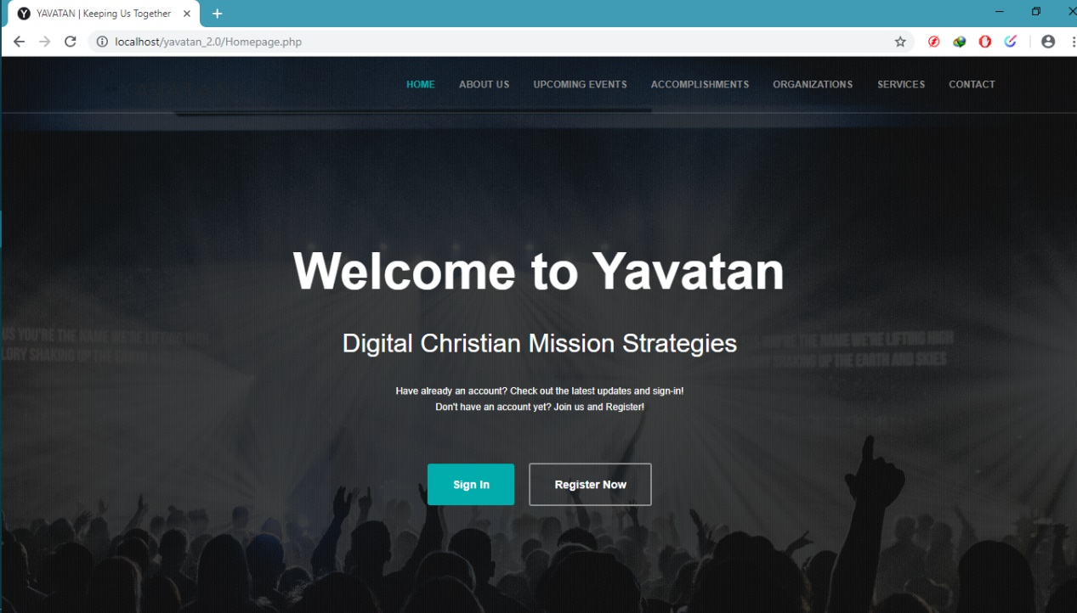

**4.1**

**Homepage**

The figure above is shown before accessing the system’s Login Form.



**4.2**

**Login Page**

The figure above is used to input user’s essential information regardless of their user role to access the system.

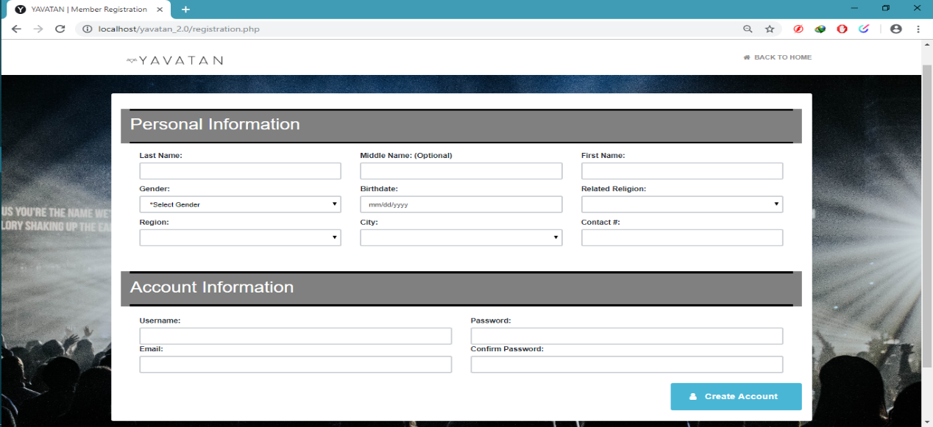

**4.3**

**Registration Page**

The figure above is used to register an account, once all the required field is filled the account will be created as volunteer account.

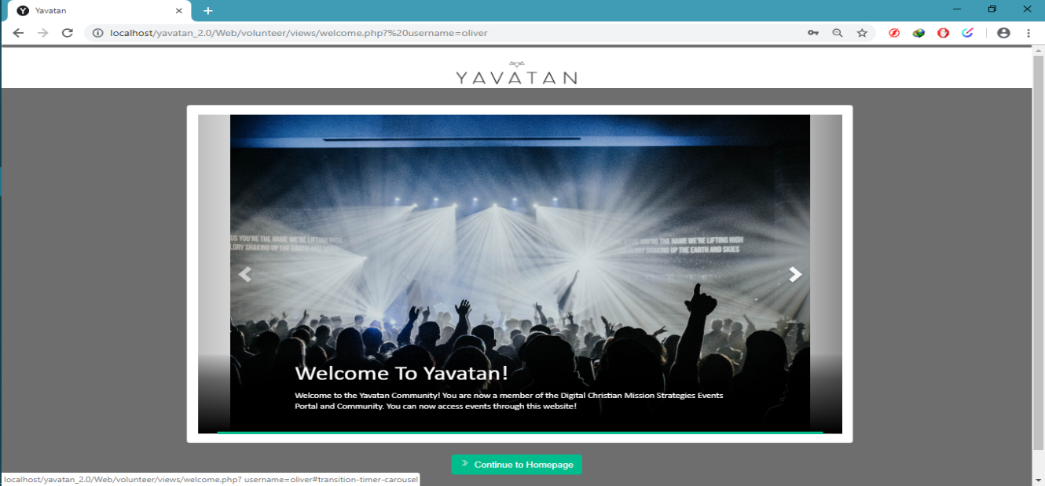

**4.4**

**Welcome Page**

The figure above is shown after you fill-up all the required information in the registration page, you are redirected to the welcome page.

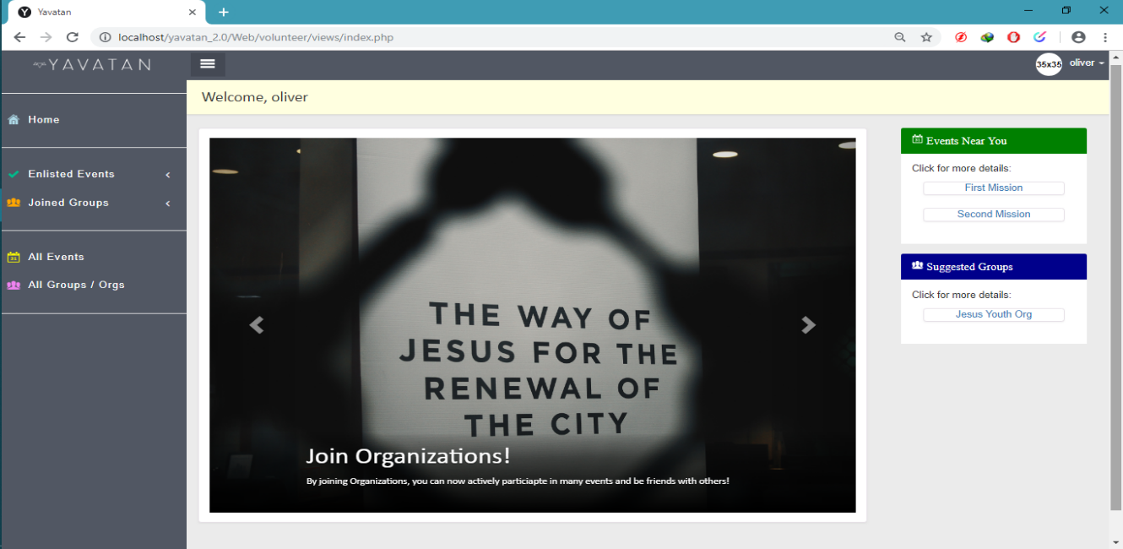

**4.5**

**Homepage (Volunteer’s Page)**

The Figure above is used where the volunteer logs in, they can see the events near them and suggested group.

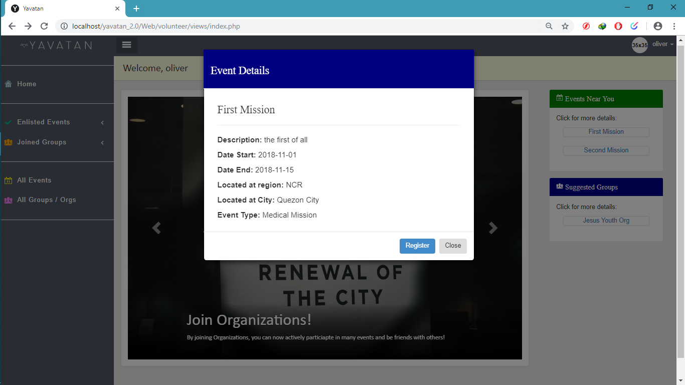

**4.6**

**Event Details (Volunteer’s Page)**

The Figure above is used to view the details of the event you clicked.

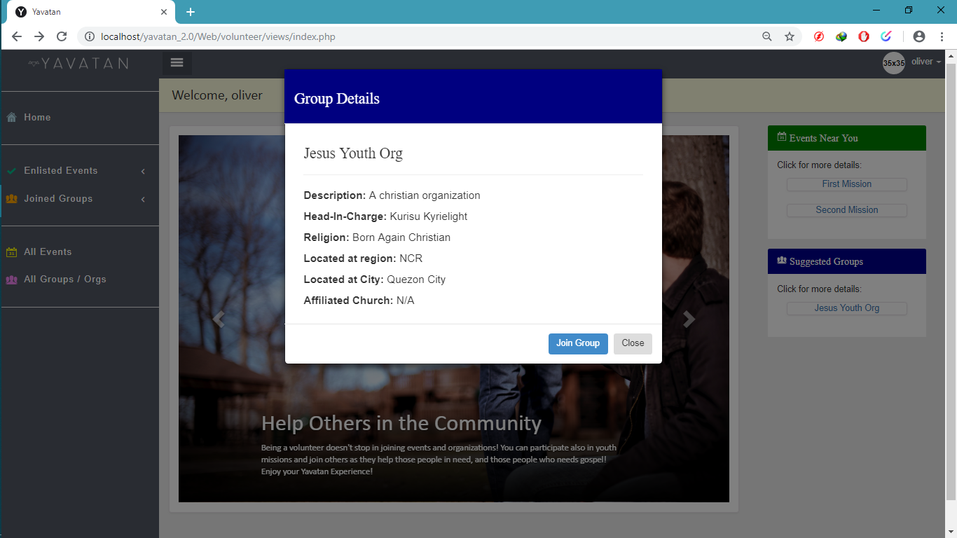

**4.7**

**Group Details (Volunteer’s Page)**

The Figure above is used to view the details of the group you want to see.

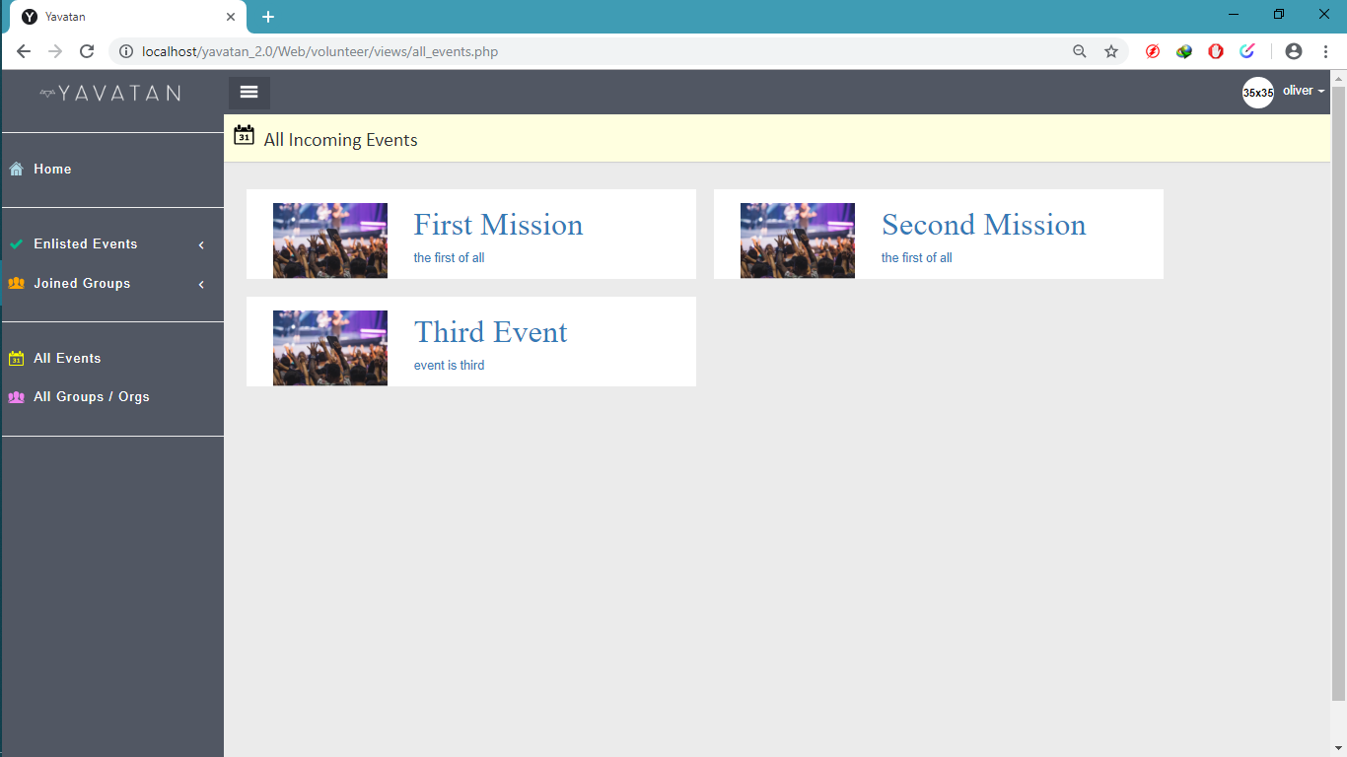

**4.8**

**All Incoming Events (Volunteer’s Page)**

The Figure above is used where the volunteer can see all the events created by the group-leaders regardless of the volunteer’s religion.

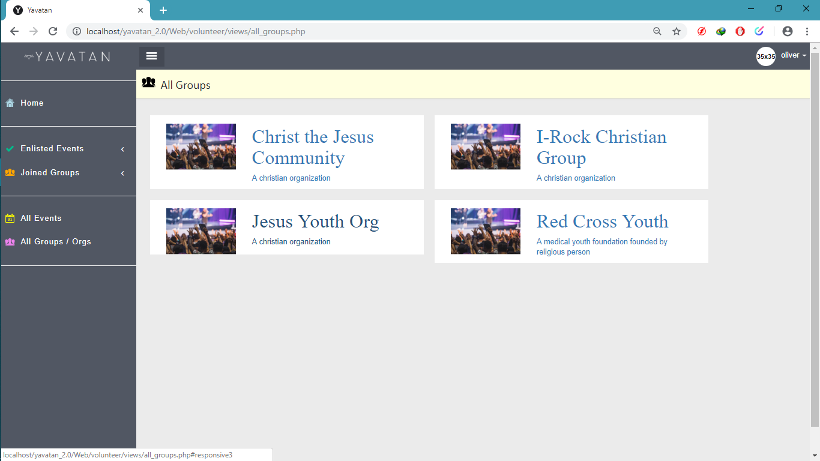

**4.9**

**All Groups (Volunteer’s Page)**

The Figure above is used where the volunteer can see all the groups existing in the system, they can see all the groups regardless of the volunteer’s religion.

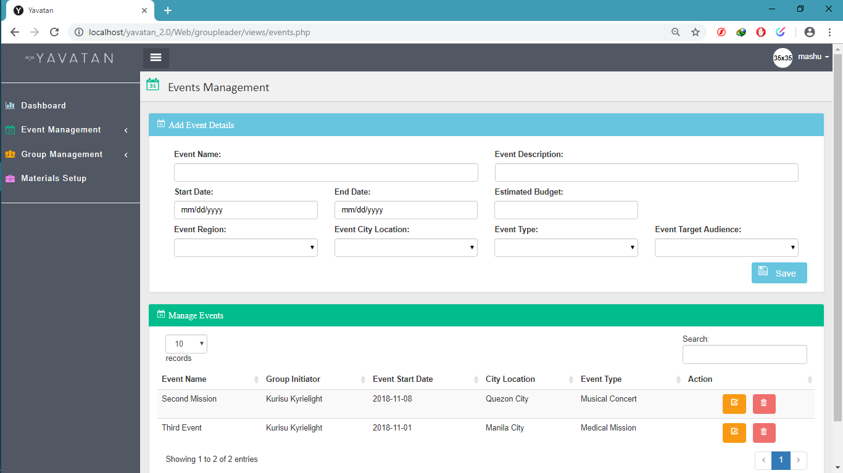

**4.10**

**Events Management (Group-Leader’s Page)**

The Figure above is used to create events, update events and also archive events.

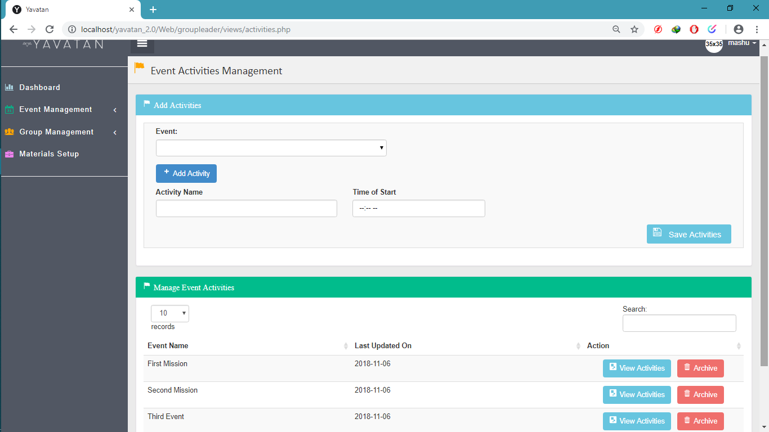

**4.11**

**Event Activities Management (Group-Leader’s Page)**

The Figure above is used to add activities in the events, also you can edit and archive activities.

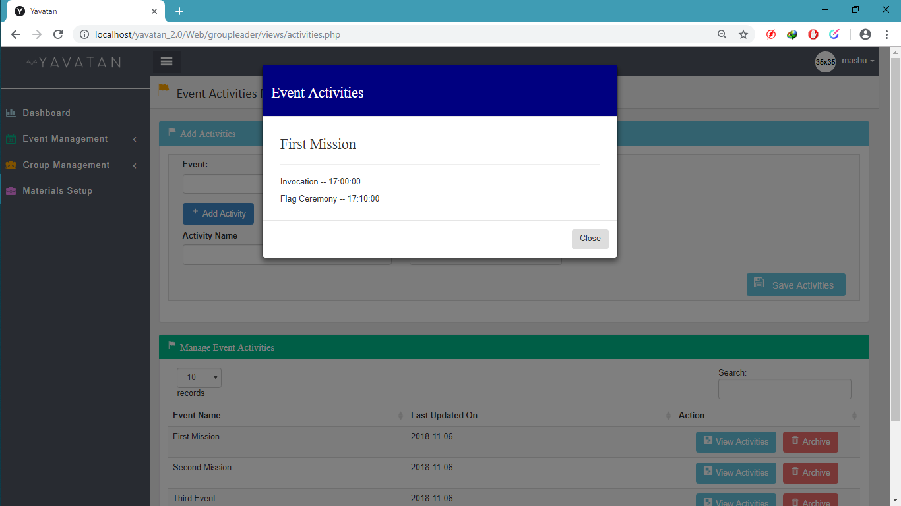

**4.12**

**View Event Activities (Group-Leader’s Page)**

The Figure above is used when you want to view activity details in specific event.

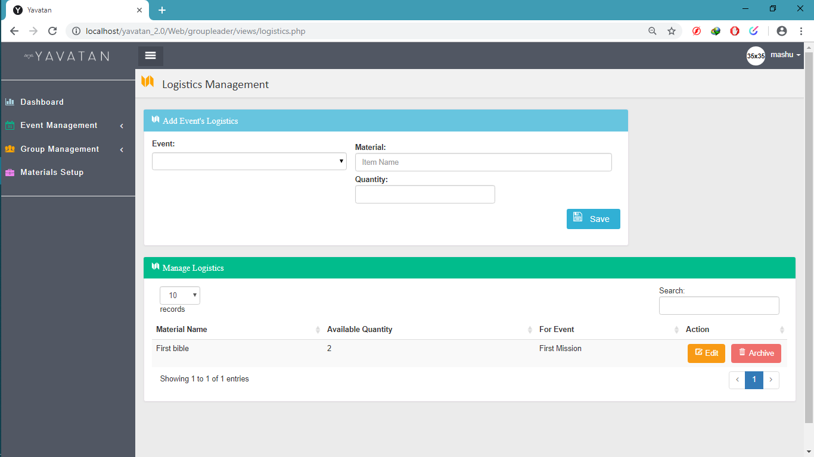

**4.13**

**Logistics Management (Group-Leader’s Page)**

The Figure above is used to add logistics in the selected events, edit is also provide and archive.

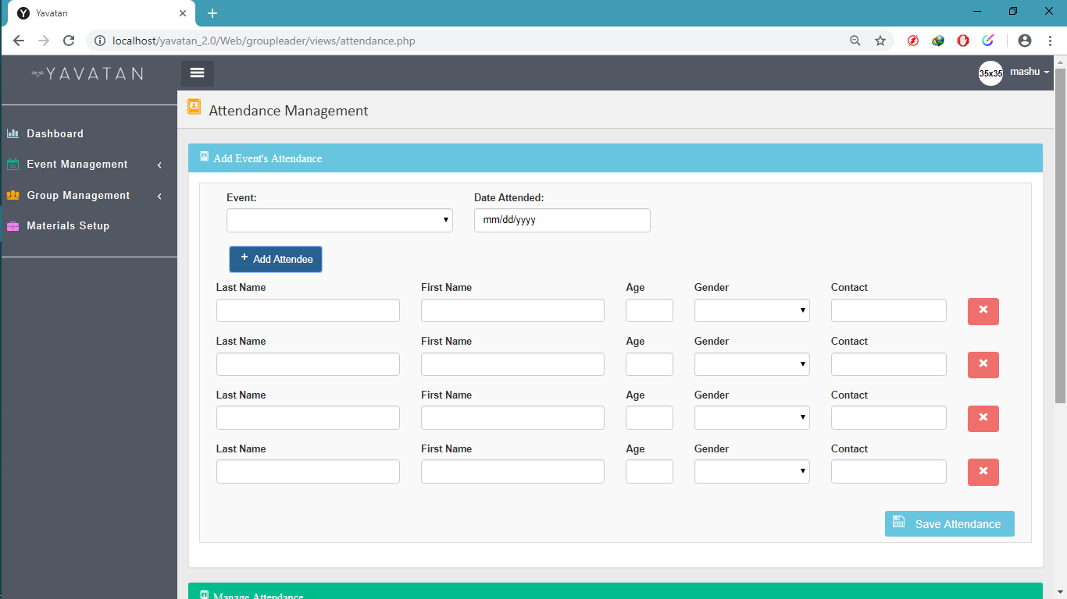

**4.14**

**Attendance Management (Group-Leader’s Page)**

The Figure above is used to add attendee in the selected event.

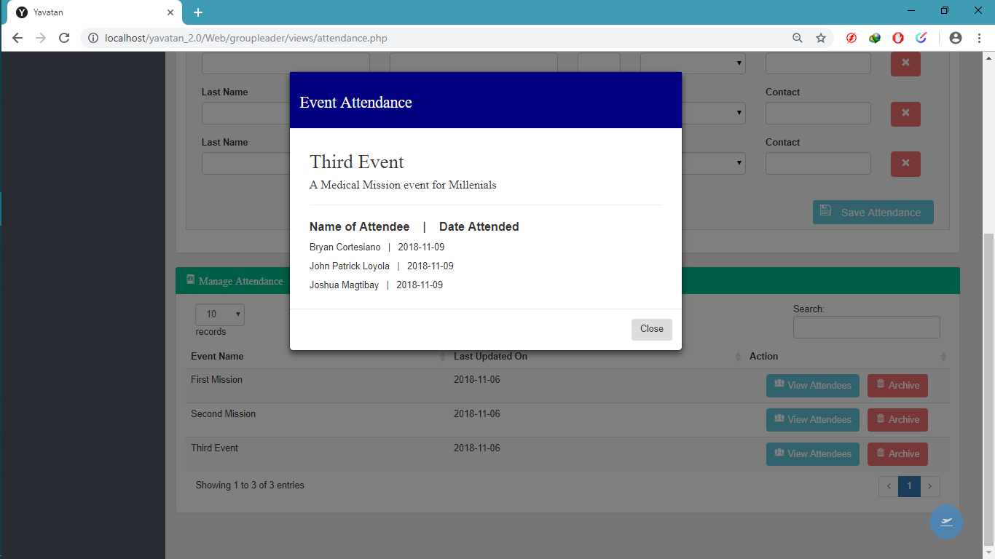

**4.15**

**View Attendance (Group-Leader’s Page)**

The Figure above is used to view all the attendees in the selected events you want to see.

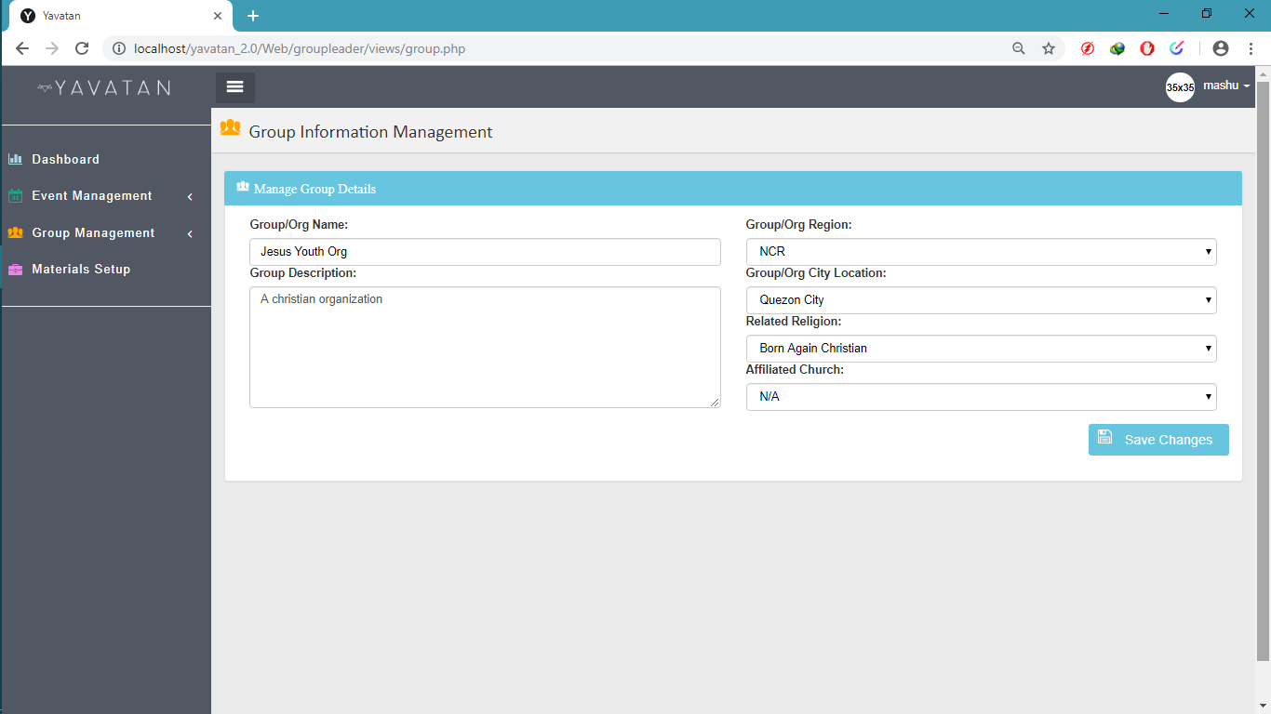

**4.16**

**Group Information Management (Group-Leader’s Page)**

The Figure above is used to manage the group details of the group leader.

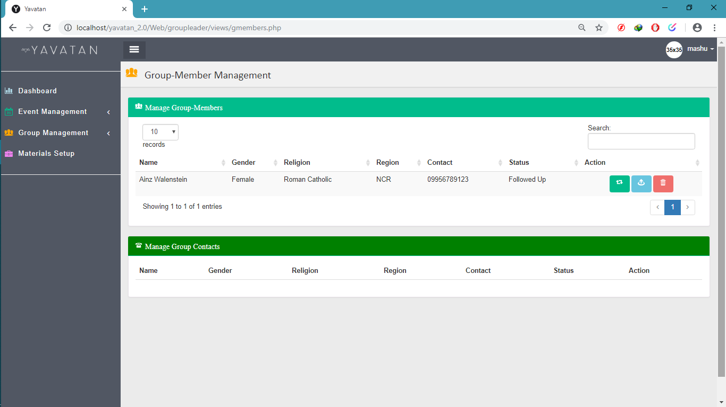

**4.17**

**Group-Member Management (Group-Leader’s Page)**

The Figure above is used to manage all the listed members of the group.

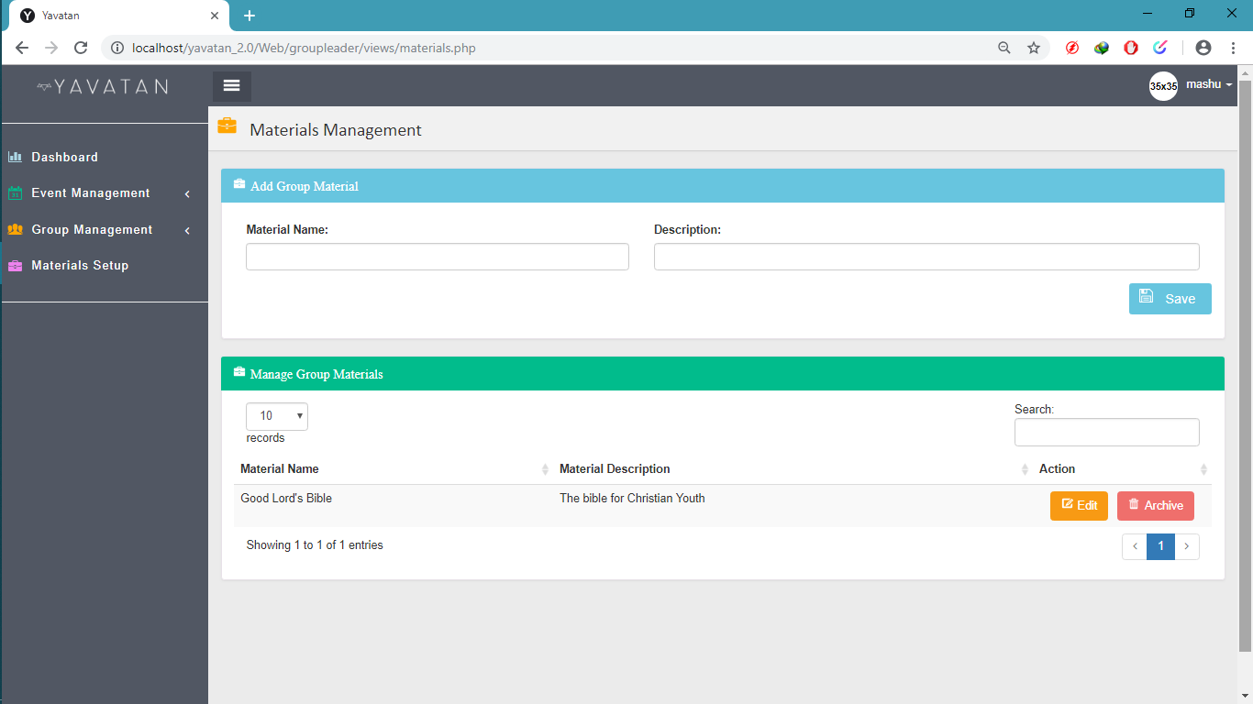

**4.18**

**Materials Management (Group-Leader’s Page)**

The Figure above is used where the group leader can manage all the materials used in the events or group.

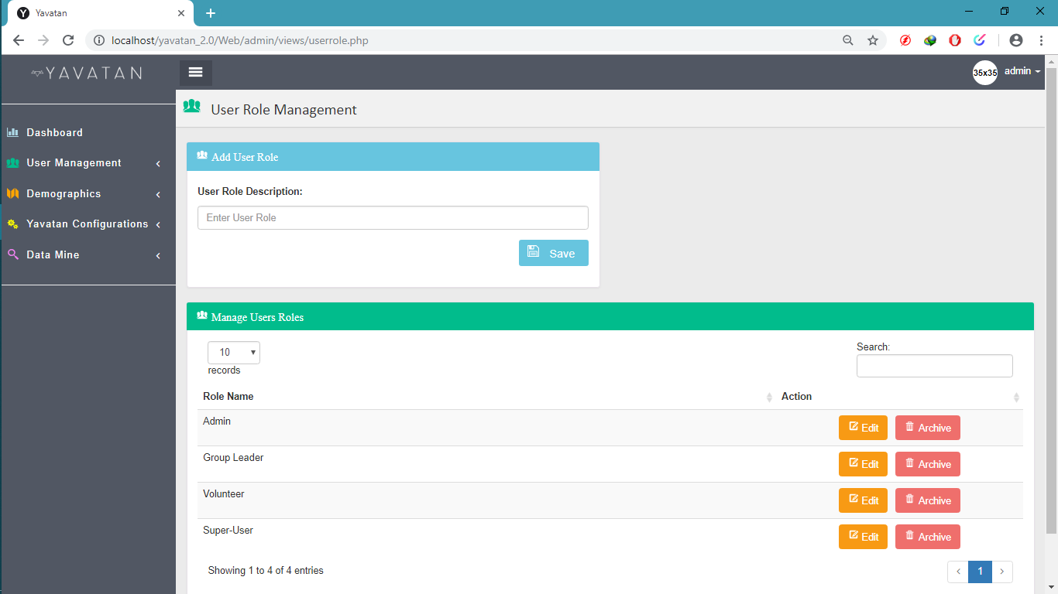

**4.19**

**User Role Management (Admin’s Page)**

The figure above is used to add, update and archive user roles.

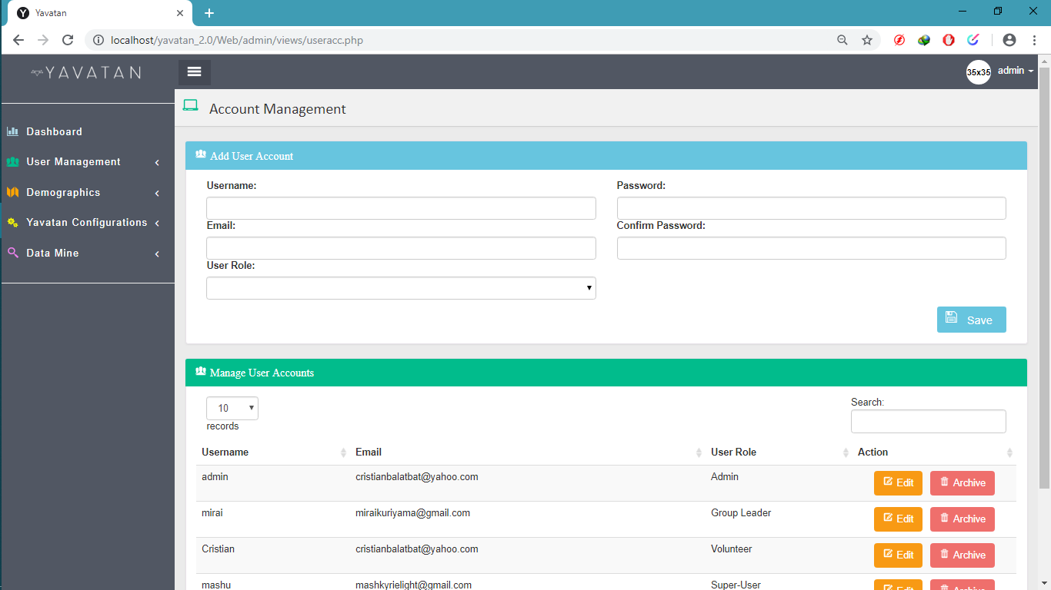

**4.20**

**Account Management (Admin’s Page)**

The figure above used to manage accounts in the system.

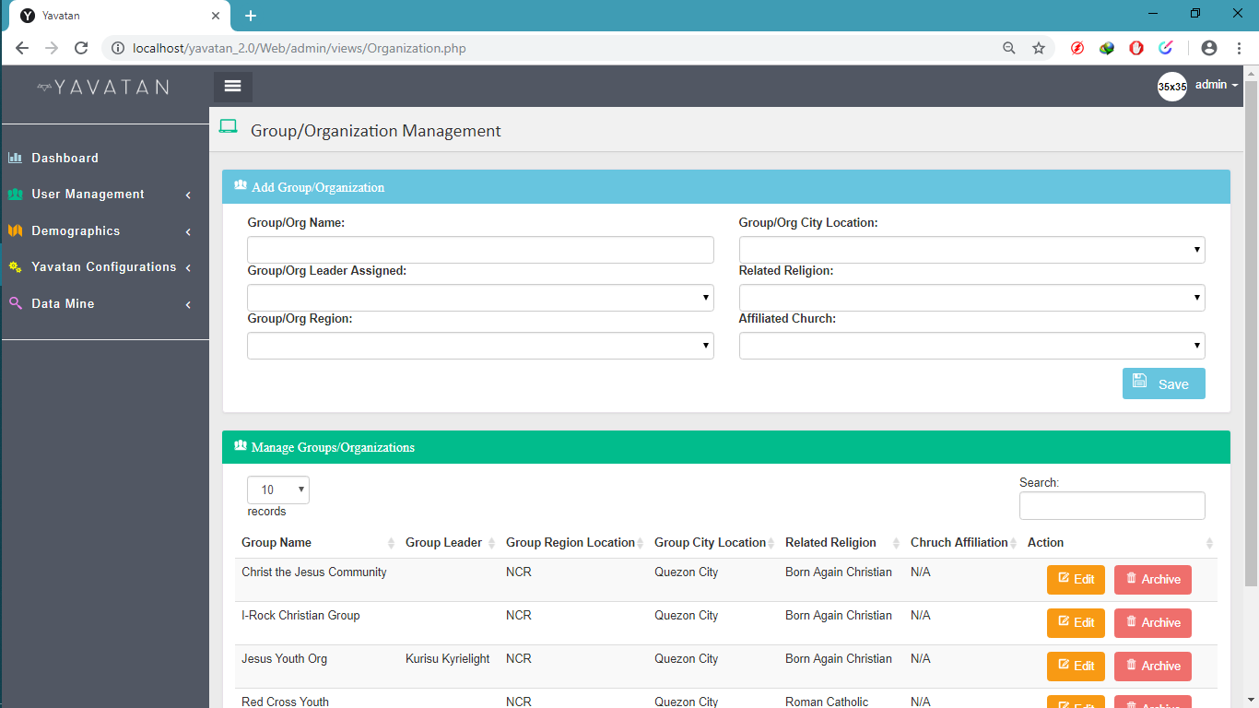

**4.21**

**Group/Organization Management (Admin’s Page)**The figure above shows all the group/organization created, you can view their details, add, edit and archive.

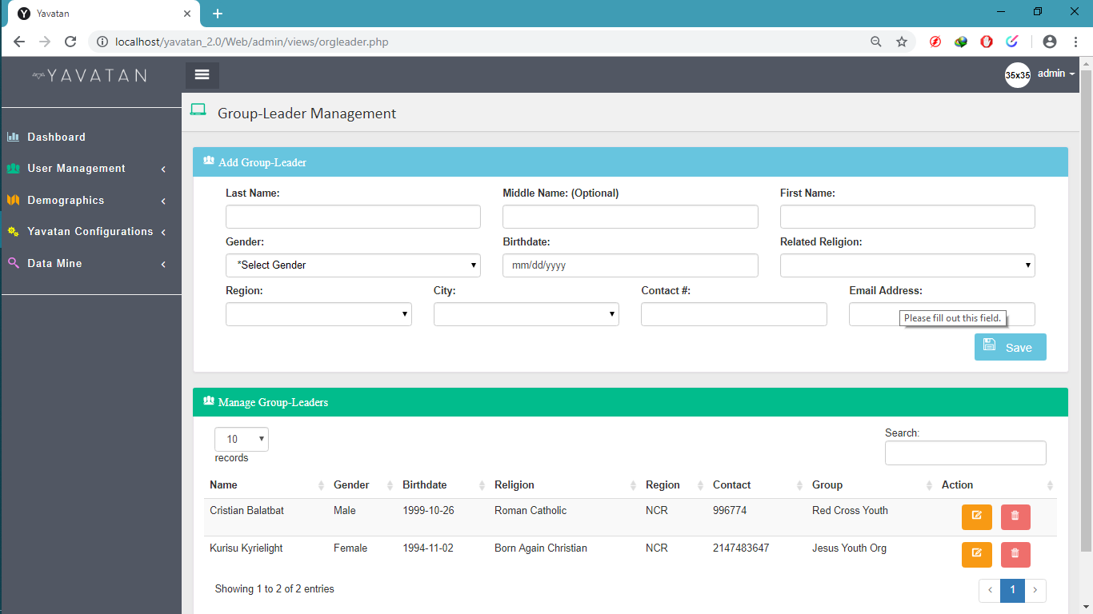

**4.22**

**Group Leader Management (Admin’s Page)**The figure above shows all the list of group leaders, you can add, edit and delete.

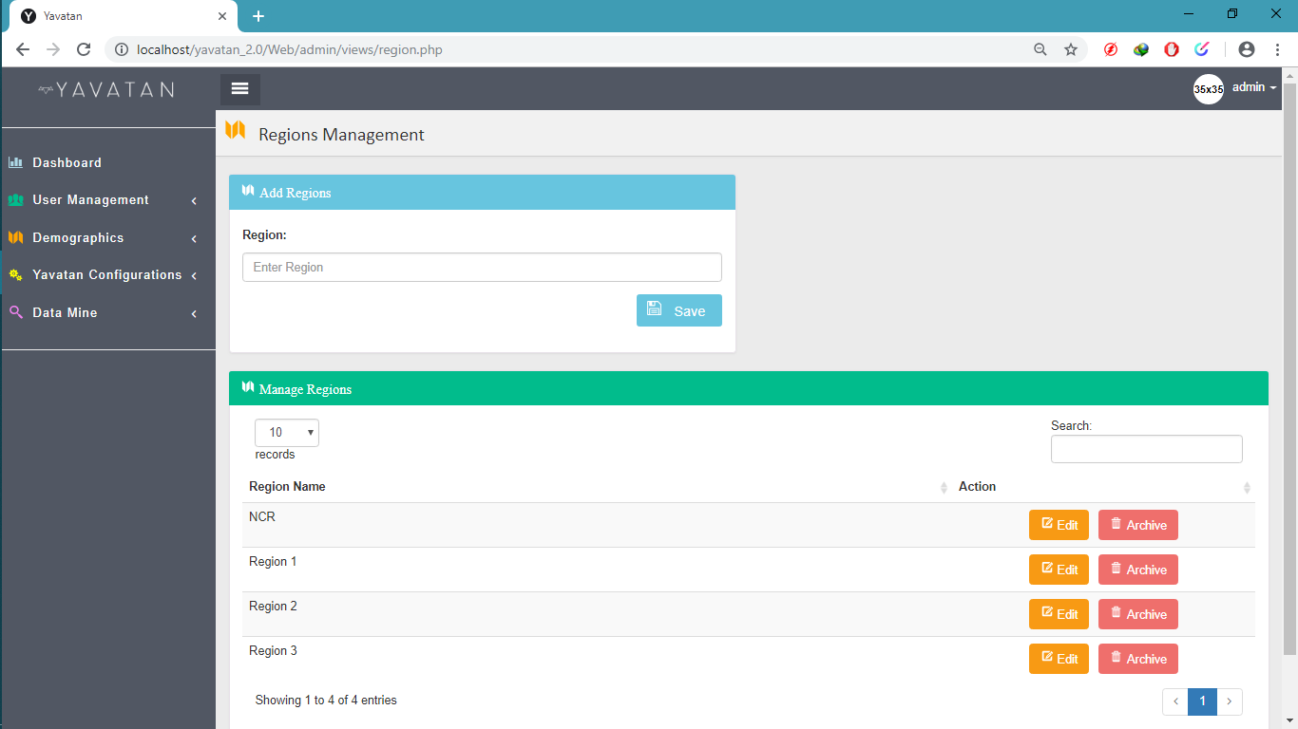

**4.23**

**Regions Management (Admin’s Page)**The figure above is used to manage regions, regions used to select where the volunteer address located.

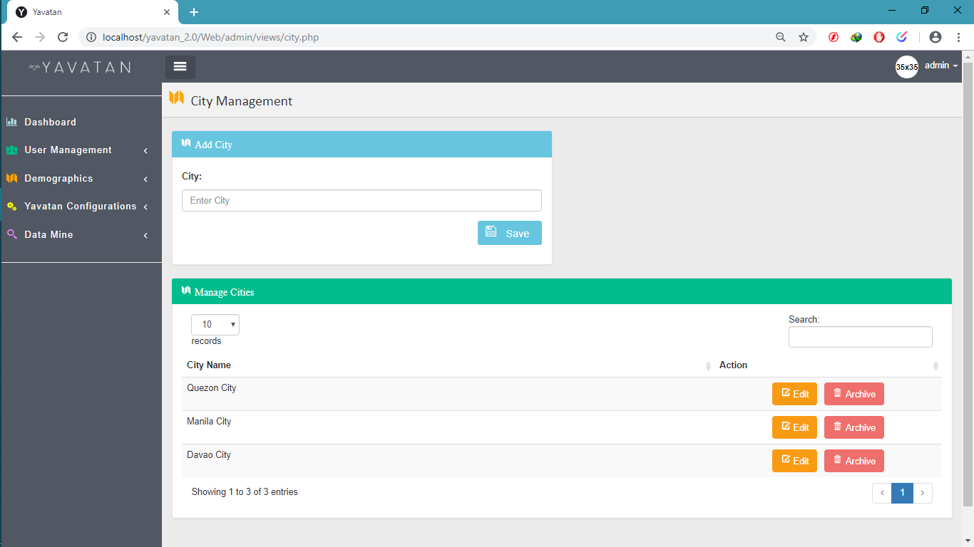

**4.24**

**City Management (Admin’s Page)**The figure above is used for the administrator where he/she can manage cities.

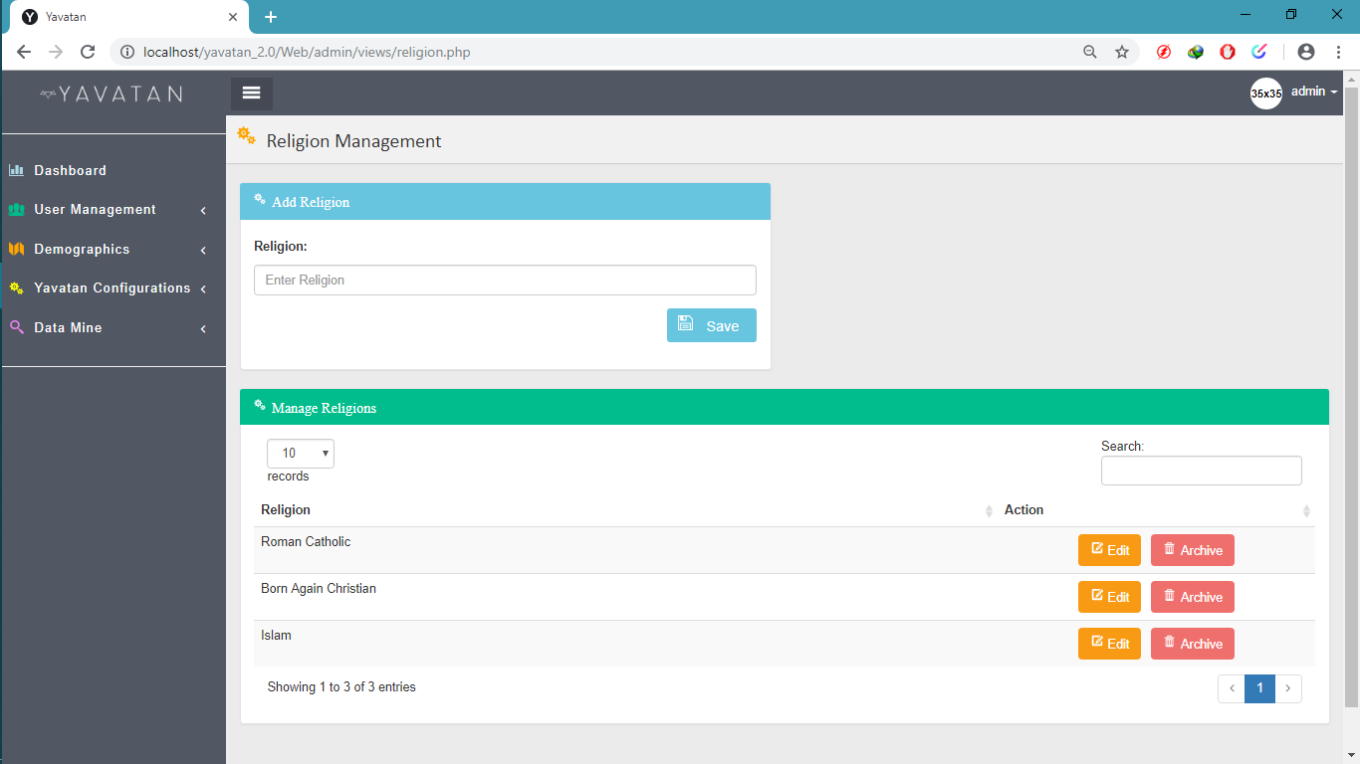

**4.25**

**Religion Management (Admin’s Page)**The figure above is used to manage religion that will used by the system.

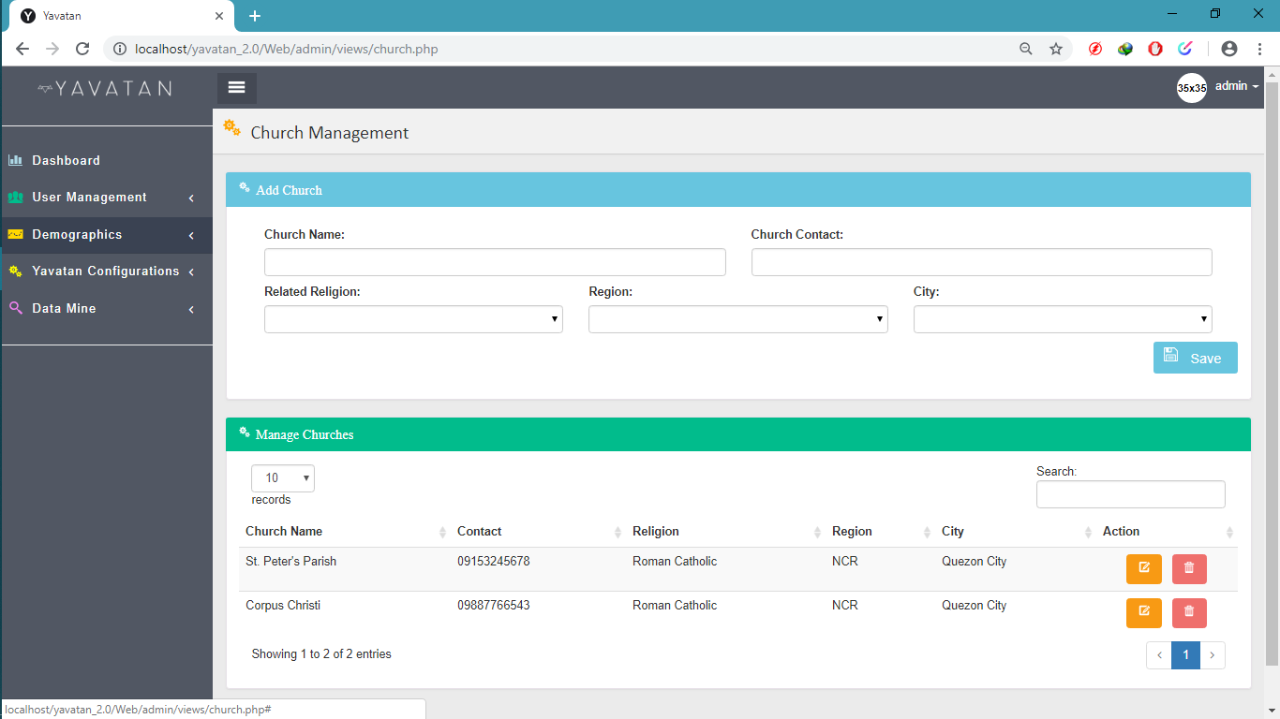

**4.26**

**Church Management (Admin’s Page)**The figure above is used by the administrator to view, add, edit and archive churches.

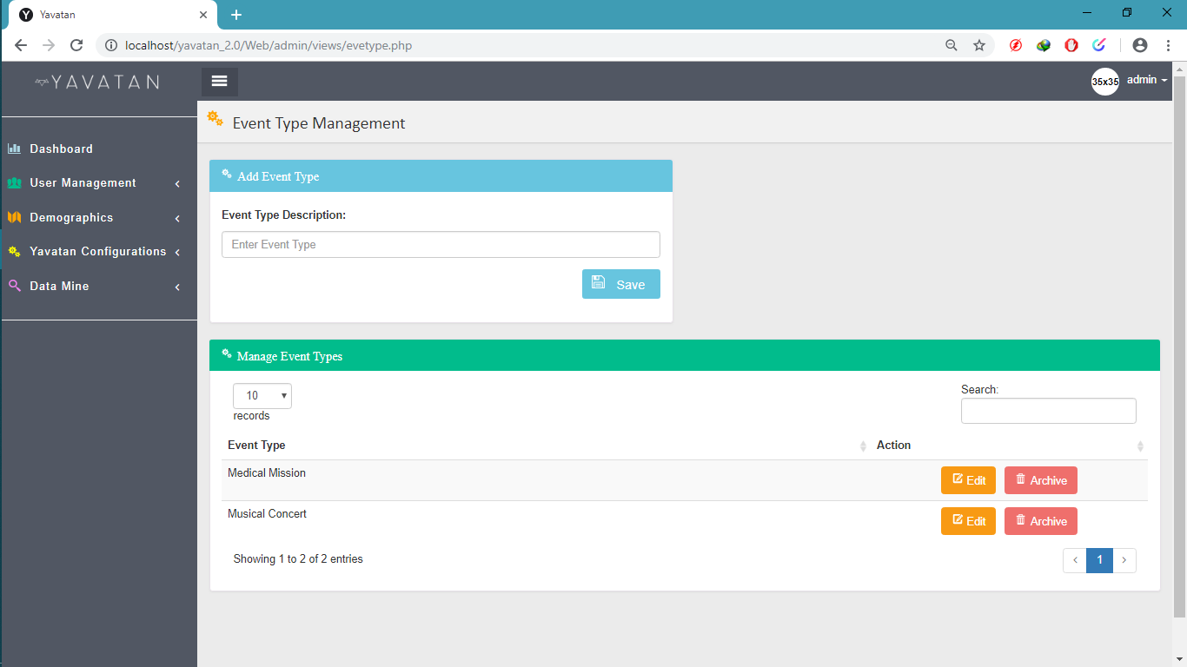

**4.27**

**Event Type Management (Admin’s Page)**

The Figured above is used to add, edit and archive event types.

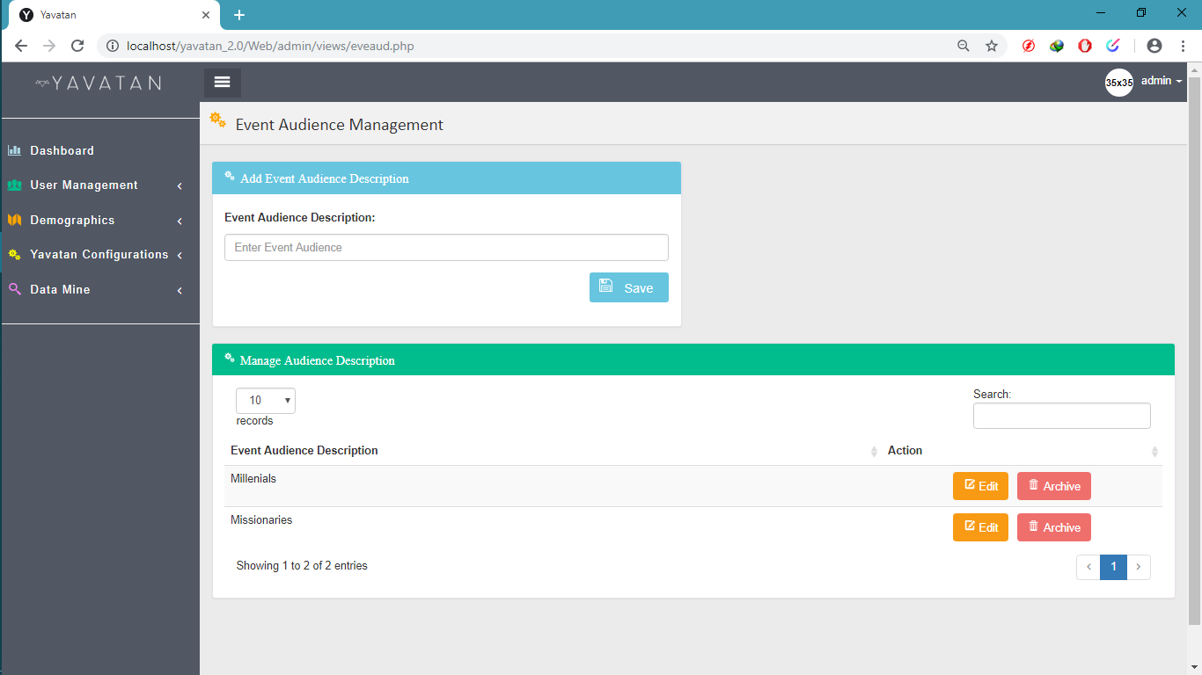

**4.28**

**Event Audience Management (Admin’s Page)**

The Figure above is used to view, add edit and archive events audience.

religion.